Instructions for abstract preparation for
Национална научна конференция по метеорология, хидрология и околна среда – 2026

I. Petrov¹, M. Ivanova² and G. Georgiev²

¹Department of Meteorology, National Institute of Meteorology and Hydrology, Sofia, Bulgaria
²Department of ……….., Sofia University “St. Kliment Ohridski”, Sofia, Bulgaria
Keywords: first, second, third, fourth, fifth.
Presenting author email: i.petrov@somewhere.edu

Introduction
Please use this template for abstract preparation and submit your abstract in .pdf format.
The abstract should be in double column (like this example) and ONE page long (any additional page will be automatically deleted). Use A4 page set-up and make all margins (top, bottom, left, right) 20 mm wide. Use 10 pt Calibri font (except for the title which should be in 12 pt bold and in sentence case). Centre the title, the authors’ names, the addresses, keywords, conference topics and contact email address. Please compose a title that clearly and succinctly describes the content of your work, in order to maximise its impact.
Methodology
Start each paragraph, except the first, with an indent. Justify the body of the text both left and right. Do not use page numbers. Keywords and listing of associated topics are there to draw attention to your abstract, and to help the organisers allocate the abstract to the most appropriate reviewers and conference session.
Use clear English to write your abstract, with an emphasis on describing what is new and why it should attract the attention of the audience.
Figures can be in colour or in black and white. Ensure that Figures and Tables have a caption and that they are numbered consecutively.

Table 1. Comparison between theoretical predictions and experimental measurements.
Month | Measured (μg/m3) | Predicted (μg/m3)
Feb | 0.4 | 0.4711
Jun | 2.4 | 1.528×10⁴

References should be made in the style (Rosner, 2000), Fernandez de la Mora and Kozlowski (2013) or as Neubauer et al (2010). Examples of references are shown below. Leave a blank line above the list of references, and also above the acknowledgements.
Section headings can be used, but they do take up valuable space: the same can be said of equations.

Abstract review
- Abstracts will be reviewed by the Program Committee. Abstracts which do not fulfil the standards will be rejected. Please avoid submitting abstracts containing only future results.
- Accepted abstracts will be placed on the NIMH website. Abstract titles and author lists will be listed in the conference handbook.
- Participants should not make requests for oral presentation of several papers on similar subjects. We recommend submitting only the most general paper for oral presentation and the others for poster presentation.
The abstract should be send to conference@meteo.bg in doc. and pdf format.
The deadline for abstract submission is February 16, 2026. Pease try to submit the abstract well in advance to avoid last moment troubles.

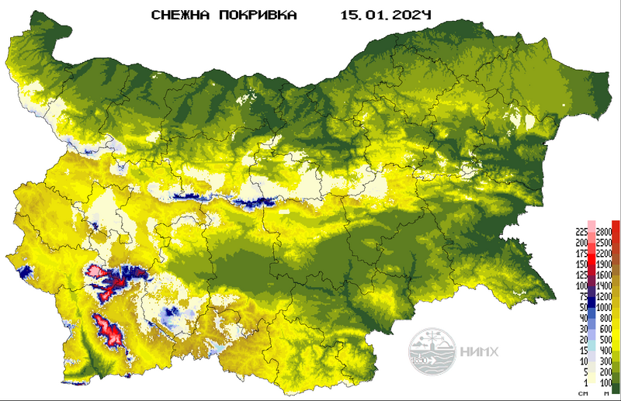

Figure 1. ……………………………………………...

This work was supported by the National Council for Research under grant JC/2102.

Annual reports, Available online: URL:........ (accessed on 7 June 2019)
Balabanova, Sn. (2021). Bul. J. Meteo & Hydro, 16/1.
Neubauer, N., Seipenbusch, M. and Kasper, G. (2010). Proc. European Aerosol Conference, EAC2010, Granada.

